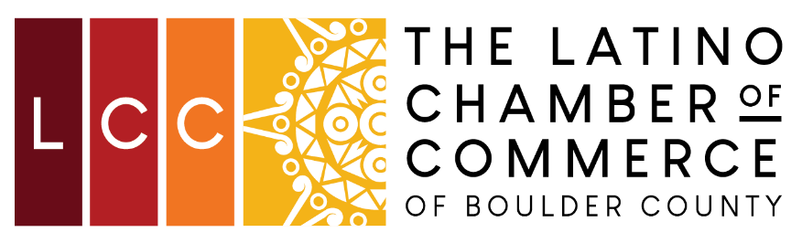

2021 Annual Membership Meeting
Proposed Amendment to Bylaws
It is proposed that The Latino Chamber of Commerce of Boulder County’s Bylaws be amended as follows:

ARTICLE IV - Board of Directors
Section 4: Election Procedures and Terms of Office
Floor Nominations. Nominations may be made from the floor of the Annual Meeting of the Members. Names may be placed by self-nomination, or by nomination by another Chamber member.
Proposed amendment: Delete paragraph from bylaws

