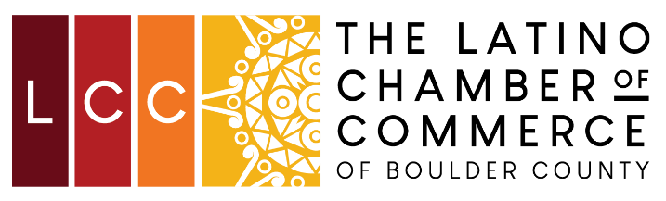
The Latino Chamber of Commerce of Boulder County
Annual Membership Meeting
Saturday, Dec. 03, 2022, | 9:00 am – 11:00 am

AGENDA

- Welcome
  - Call Meeting to Order
  - Credentials Committee Report
  - Determine Membership Quorum (10% required)
  - Introductions
- Action Items
  - Report
    - 2022 Report
    - Strategic Plan Goals
    - 2023 Programing
  - 2023 Budget Approval
  - PT Admin Position Approval
- Nominations
  - Board of Director nominations
  - Floor nominations
  - Board of Director elections
- Officer Nominations
  - Chair
  - Vice Chair
  - Treasurer
  - Secretary
- Meeting calendar for 2022
  - Monthly Board Meetings

- Other Business
- Meeting Adjourned

