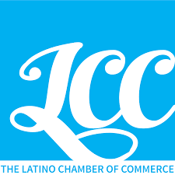
The Latino Chamber of Commerce of Boulder County
Board Meeting
Saturday, December 14, 2019, 9:00 – 10:00 PM

- Welcome – Pete Salas

- Call meeting to Order

- Determine if a quorum is present

- Call the roll

- Committee Reports

  - Treasurers Report
  - Events Committee
  - Digital Committee

- Other Business

- Adjourn Meeting

