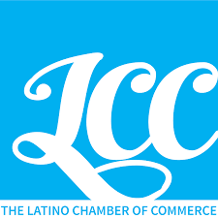
The Latino Chamber of Commerce of Boulder County
Annual Board Meeting Agenda

Saturday, December 14, 2019, 10:00 AM – 12:00 PM

- Welcome – Peter Salas – Board Chair

- Call Meeting to Order

- Credentials Committee Report

- Determine Membership Quorum (10% required)

- Introductions

- Reports
  - By-law Committee
  - Nominations Committee

- Action Items
  - By-law amendments
  - Board nominations
  - Suspension of rules – floor nominations
  - Board elections

- Officer Nominations
- Chair
- Vice Chair
- Treasurer
- Secretary

- Set board meeting calendar for 2020

- Meeting Adjourned

